**Task 3:**

**INTRODUCTION:**

Neo-Banks are a recent development in the financial sector; they are new banks that solely operate online.

I believed that there should be some kind of connection between the digital world, these new age institutions, and cryptocurrencies.

So I made the decision to start a new project called Data Bank!

Customers of Data Bank receive cloud data storage allotments that are directly related to the balances in their accounts. The Data Bank team needs your assistance since this business model comes with some intriguing drawbacks.

This case study focuses on metrics calculations, business growth, and smart data analysis to assist the company more accurately estimate and plan for the future.

|  |  |
| --- | --- |
| regions | |
| region_id | int |
| region_name | varchar |

**Schema:**

|  |  |  |
| --- | --- | --- |
| customer_transactions | | |
| customer_id | int |
| txn_date | | date |
| txn_type | | varchar |
| txn_amount | | int |

|  |  |
| --- | --- |
| customer_nodes | |
| customer_id | int |
| region_id | int |
| node_id | int |
| start_date | date |
| end_date | date |

**CASE STUDY QUESTIONS**

1. How many different nodes make up the Data Bank network?

select count(distinct node_id) as unique_node

from customer_nodes;

Output:



1. How many nodes are there in each region?

SELECT r.region_name, COUNT(DISTINCT cn.node_id) AS unique_node_count

FROM customer_nodes cn

JOIN regions r ON cn.region_id = r.region_id

GROUP BY r.region_name;

Output:

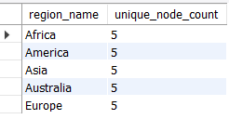

1. How many customers are divided among the regions?

SELECT r.region_name, COUNT(DISTINCT cn.customer_id) AS unique_customer_count

FROM customer_nodes cn

JOIN regions r ON cn.region_id = r.region_id

GROUP BY r.region_name;

Output:

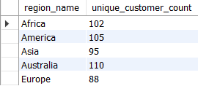

1. Determine the total amount of transactions for each region name.

SELECT r.region_name, SUM(t.txn_amount) AS total_transaction_amount

FROM customer_transactions t

JOIN customer_nodes cn ON t.customer_id = cn.customer_id

JOIN regions r ON cn.region_id = r.region_id

GROUP BY r.region_name

ORDER BY total_transaction_amount DESC;

Output:

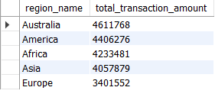

1. How long does it take on an average to move clients to a new node?

SELECT round(avg(datediff(end_date, start_date)), 2) AS avg_days

FROM customer_nodes

WHERE end_date!='9999-12-31';

Output:



1. What is the unique count and total amount for each transaction type?

SELECT

txn_type,

COUNT(DISTINCT customer_id) AS unique_transaction_count,

SUM(txn_amount) AS total_amount

FROM

customer_transactions

GROUP BY

txn_type;

Output:

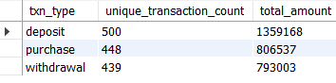

1. What is the average number and size of past deposits across all customers?

WITH customer_deposits AS (

SELECT customer_id,

COUNT(*) AS num_deposits,

SUM(txn_amount) AS total_deposit_amount

FROM customer_transactions

WHERE txn_type = 'deposit'

GROUP BY customer_id

)

SELECT

AVG(num_deposits) AS avg_deposits_per_customer,

AVG(total_deposit_amount) AS avg_deposit_amount_per_customer

FROM customer_deposits;

Output:



1. For each month - how many Data Bank customers make more than 1 deposit and at least either 1 purchase or 1 withdrawal in a single month?

WITH txn_with_month AS (

SELECT

customer_id,

txn_type,

DATE_FORMAT(txn_date, '%Y-%m') AS txn_month

FROM customer_transactions

),

deposit_counts AS (

SELECT

customer_id,

txn_month,

COUNT(*) AS deposit_count

FROM txn_with_month

WHERE txn_type = 'deposit'

GROUP BY customer_id, txn_month

),

pw_flags AS (

SELECT DISTINCT

customer_id,

txn_month

FROM txn_with_month

WHERE txn_type IN ('purchase', 'withdrawal')

),

qualified_customers AS (

SELECT d.customer_id, d.txn_month

FROM deposit_counts d

JOIN pw_flags p

ON d.customer_id = p.customer_id AND d.txn_month = p.txn_month

WHERE d.deposit_count > 1

)

SELECT

txn_month,

COUNT(DISTINCT customer_id) AS qualified_customer_count

FROM qualified_customers

GROUP BY txn_month

ORDER BY txn_month;

Output:

